Word document with plots and Images

Introduction
This Word document is created using R software and ReporteRs package. The goal of this section is to show you how to add plots and images into a Word document. This can be done easily using the functions addPlot() and addImages().

Box plot using R software
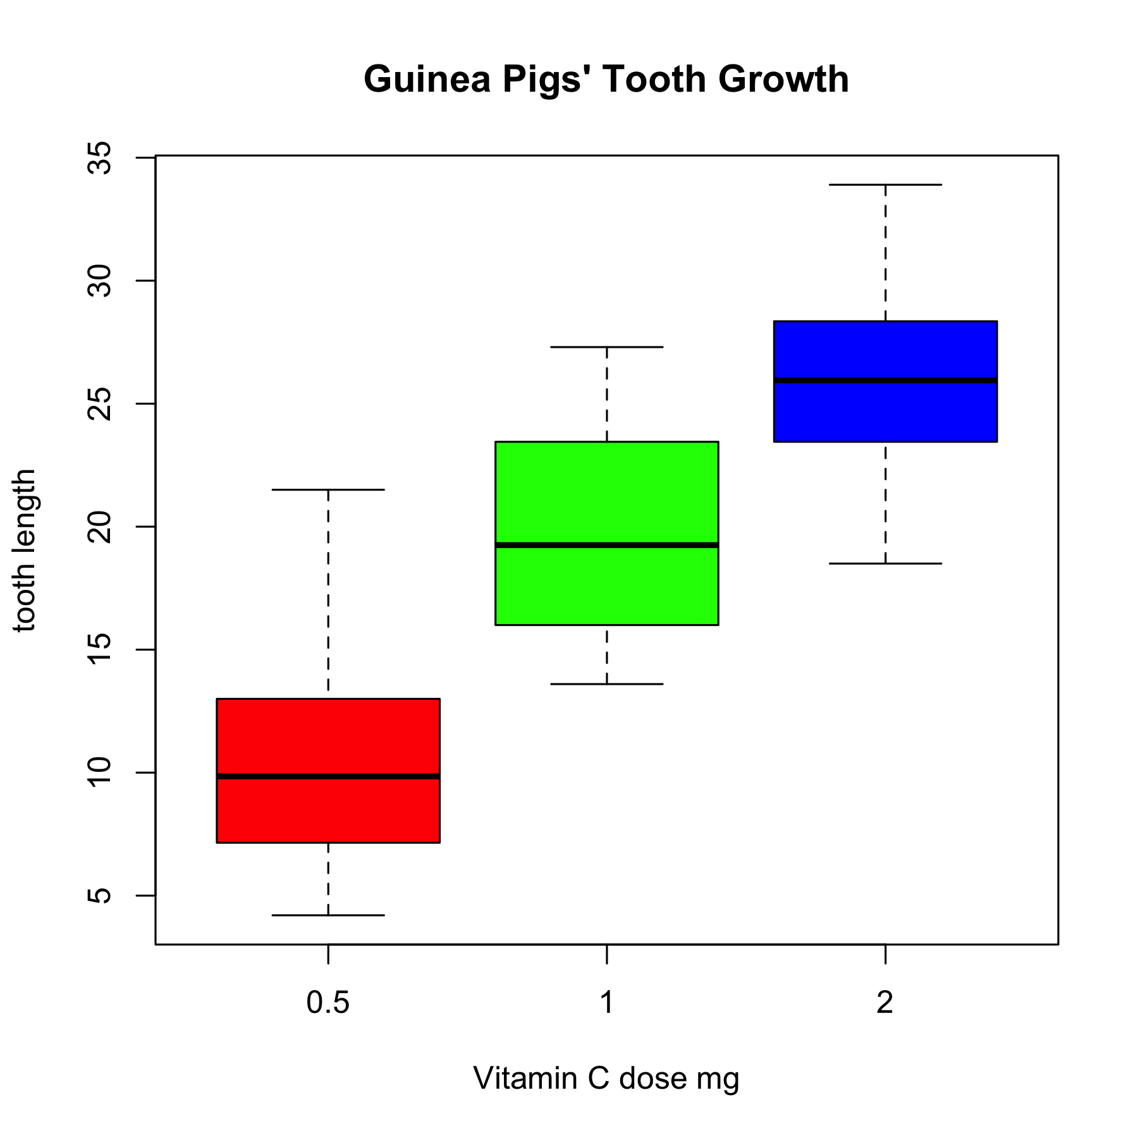

Histogram plot
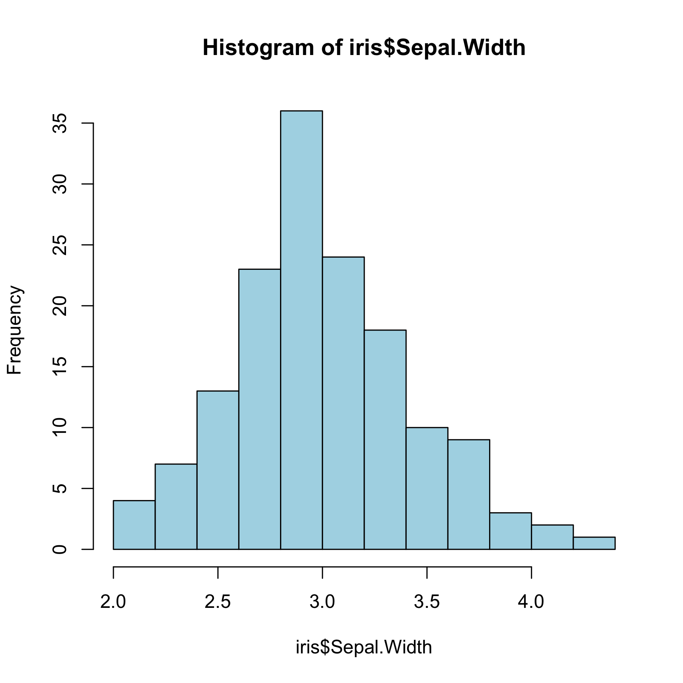

Histogram with pointsize = 18
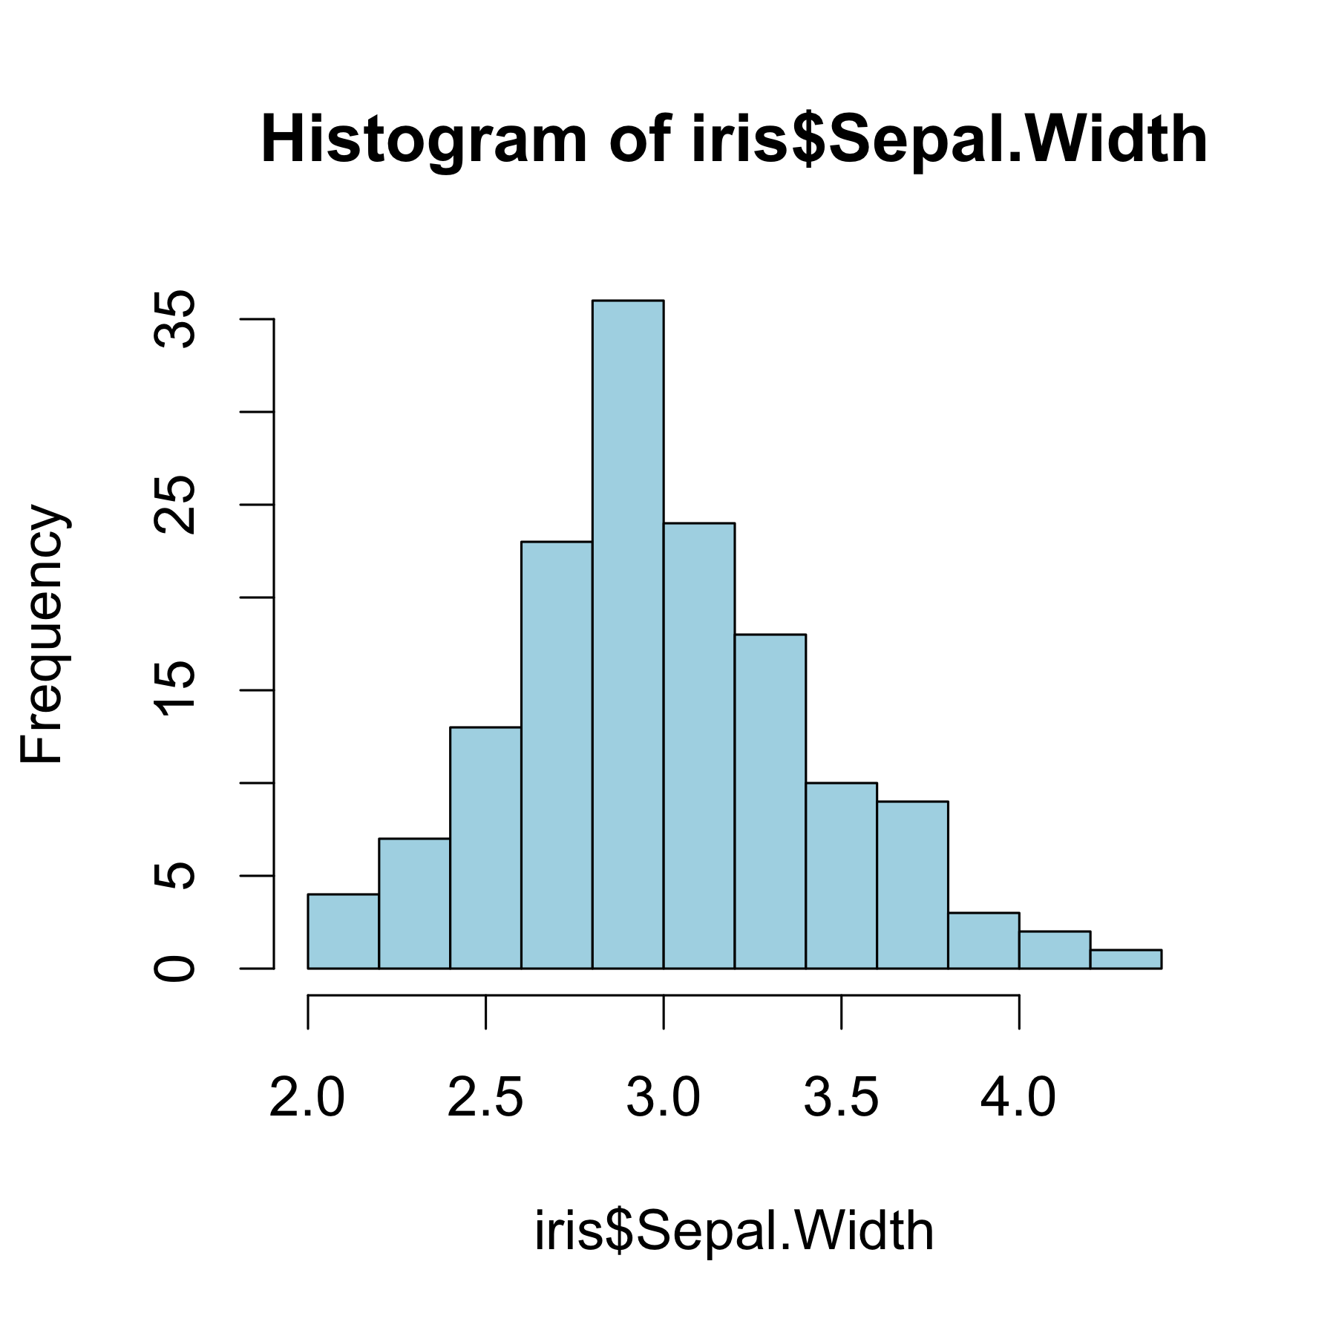

Image from STHDA web site
