Create a Word document with TOC
1 Create a Word document with TOC 1
1.1 Introduction 2
1.2 Box plot using R software 2
1.3 Basic plots using R software 3
1.3.1 Histogram 3
1.3.2 Bar plot 4

Introduction
This Word document is created using R software and ReporteRs package. The goal of this section is to show you how to add a table of contents into a Word document. This can be done easily using the function addTOC.

Box plot using R software
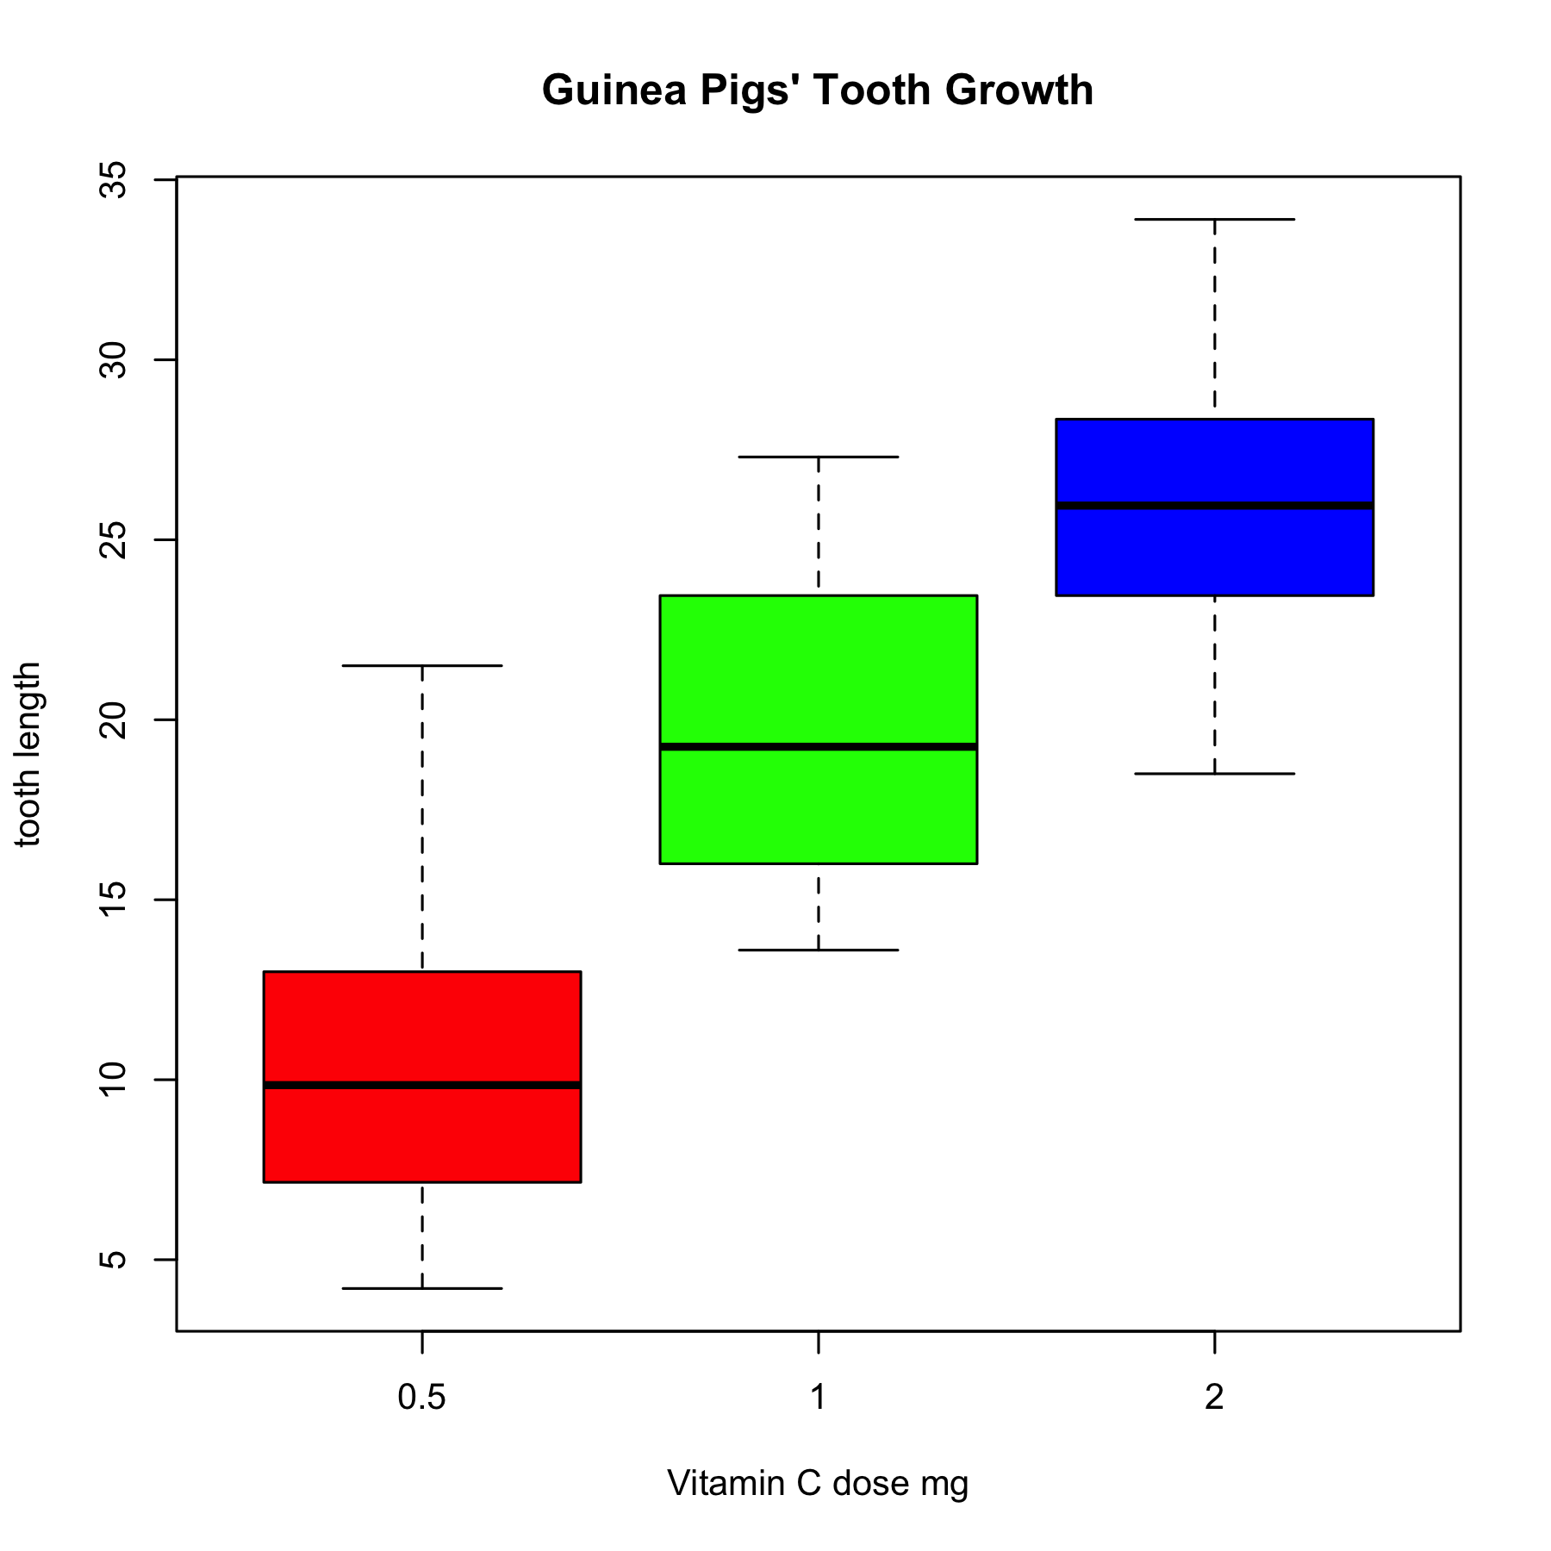

Basic plots using R software
R is a free software for plotting and data analysis. This chapter contains examples of graphs generated using R.

Histogram
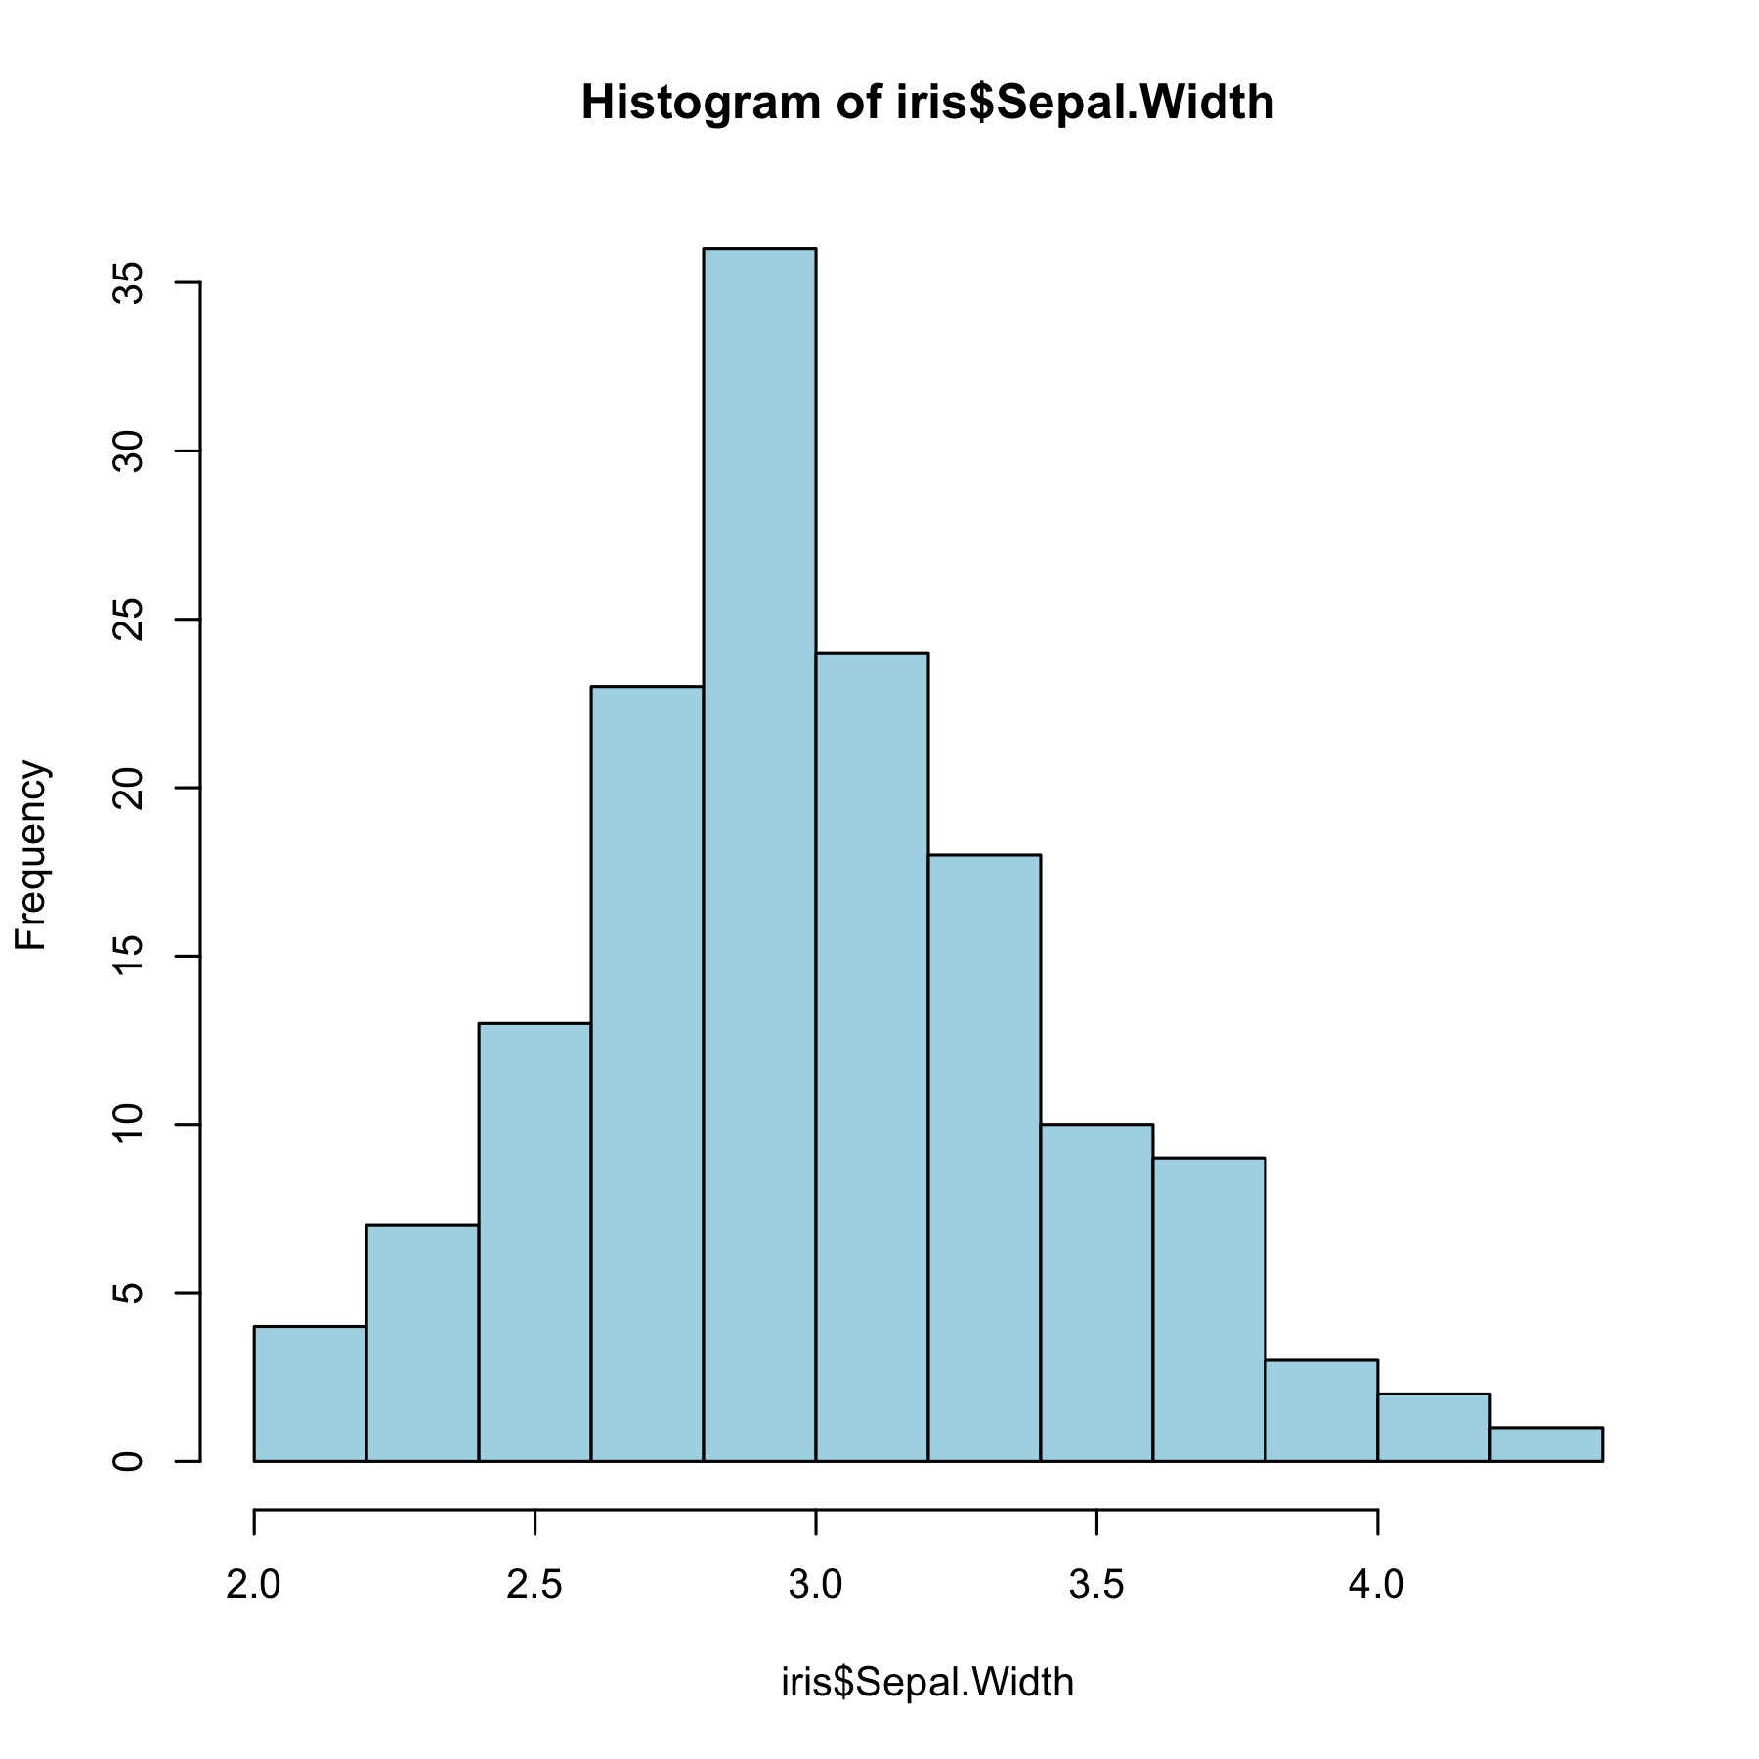

Bar plot
